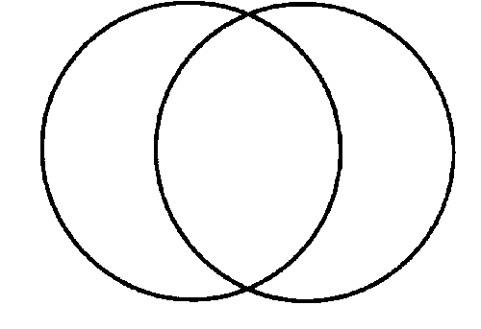
Setting:
Characters:
Magic:
Message:
Setting:
Characters:
Magic:
Message:
Setting:
Characters:
Magic:
Message:

